
JATHNIER CORPORATION
RUBY ST., RGA VILLAGE, DACUDAO,
DAVAO CITY, PHILIPPINES.
(082) 282 2439
M E M O R A N D U M
WMD.MEMO-2023-01-004
January 18, 2023

TO: Operations

Cc: VP/Operations Director, General Manager, HR Department, Purchasing Department

FR: Warehouse Management Department
Subject: ISSUANCE AND WITHDRAWAL CONTROL POLICY

In line with our goals and objectives for the year 2023 which is to have a clear monitoring and control of items issued to operations, we will strictly implement our issuance and withdrawal control policy. The purpose of this policy is to control the issuance and withdrawal of particular items used in the operations and related activities.

This policy covers the existing memo “No Return No Issuance and Withdrawal Policy “ WHSE MEMO 01-001 effective January 9, 2023, which helps to strengthen our implementation and control over the materials and supplies.

Items are issued based on projected monthly usage, which helps to ensure proper item utilization.
This items include, but are not limited to;
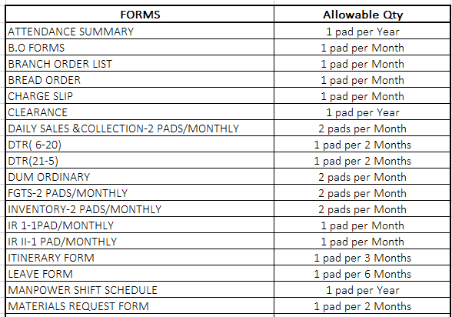

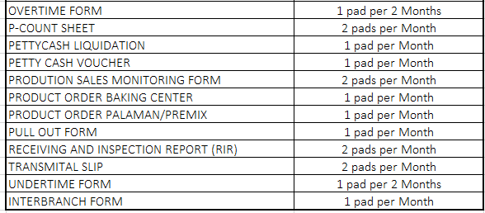

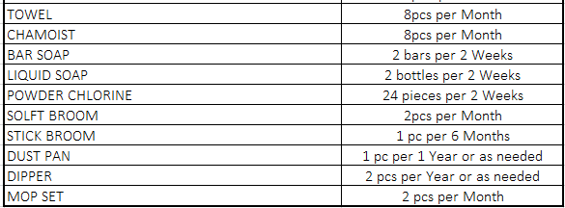

The implementation of this policy will take its effect on February 1, 2023.

Should you have any questions and clarifications, let us know.

Prepared by: Reviewed by: Approved by:
KRISTINE C. MUNDA MERAFLOR L. CARIQUITAN GABRIEL CUAYCONG
Warehouse Supervisor Asst. Operation Manager General Manager

